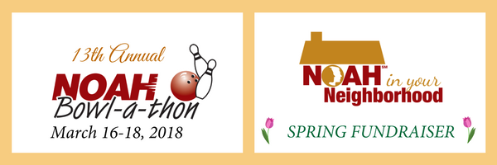
Dear _______,

This March, NOAH volunteers across the U.S. and Canada will host local events as part of a fundraiser to support the albinism community. People with albinism, commonly referred to as albinos, have reduced pigment in their skin, hair and eyes. In addition to the social stigma people with albinism experience, albinism includes some degree of uncorrectable low vision. Many people with albinism are considered legally blind.

NOAH is a 501(c)(3) nonprofit corporation (Federal Tax ID# 23-2265173) that offers information and support to people with albinism, their families, and the professionals who work with them.

I am writing on behalf of NOAH members in our community. We are seeking support from local businesses like yours to help make this year’s event a success. ___________________________________________________________________ (Include specific information about your event)

Here are a few ways you could help support NOAH:
- Sponsor the event by a cash donation. Your business will be prominently recognized at the event.
- Make and in-kind donation of items for the fundraiser such as silent auction/raffle prizes, food, or materials/services needed for the event.
- Offer discounts for materials needed for the event such as food, drink, or the cost for bowling or other activity.

Will you please consider being a hero for NOAH through a donation? Your generosity helps change lives by making it possible for NOAH to reassure and educate those affected by albinism.

Thank you very much!

Sincerely,
_____________
Feel free to contact me at
_________________ (phone)
_________________ (email)

